LG Group Budget 2019/20

Purpose of report

For decision.

Summary

LGA Leadership Board received and noted the 2019/20 Budget Assumptions (including the key themes, issues, risks and opportunities for each of the LG Group Companies and Group overall) at their meeting in January 2019.

The attached detailed proposed Budget for 2019/20 has been prepared under those assumptions and is presented for agreement as recommended by the Leadership Board.

The LG Group budget for 2019/20 allocates resources to enable the delivery of the Group’s priorities as set out in the latest Business Plan.

Recommendations

LGA Executive is asked to:

1. Agree the LG Group’s budget for 2019/20 as recommended by the LGA Leadership Board; and
2. Endorse the Leadership Board’s delegation to the Chairman and Group Leaders, in consultation with the Deputy Chief Executive, of approval to make necessary adjustments to reflect the final grant notification from MHCLG.

Action

As directed by Members

Contact officer: Jonathan Gratte

Position: Strategic Finance Manager

Phone no: 0207 187 7309

Email: jonathan.gratte@local.gov.uk

LG Group Budget 2019/20

Background

1. The proposed 2019/20 Budget for the LG Group is presented for agreement.

Issues

1. A consolidated budget has been developed for the LGA, the IDeA and the LGA’s property and commercial companies reflecting the full integration of the management and operations of these organisations, in line with the principles of the 2019/20 Financial Strategy agreed by the Leadership Board in January 2019 – the budget draws on previously created reserves in 2019/20 as we continue to invest in new income-generating activities in the year, which will deliver significant benefits in future years.
2. The 2019/20 budget has been driven by the strategy for the LGA and the priorities set out in the annual business plan. The business plan recognises that the high level priorities identified for the last five years are still broadly relevant for 2019/20.
3. In 2019/20 the LGA’s core funding is broadly at the same level as 2018/19 (including a further freeze on Subscription income), apart from a potential decrease of £1.0 million (not yet confirmed by MHCLG, but included for prudent budget purposes) in Direct Government Grant. This budgeted reduction in funding is being managed without adversely impacting on current staffing levels or operational budgets as a result of the significant overhead reductions in 2015/16, plus utilising built-up reserves.
4. The proposed Net Budget (ie the net impact on Reserves) is summarised in **Table 1** below, with more detail of the Income and Expenditure budget presented at **Appendix A**.

**Table 1**: Consolidated LG Group Proposed Net Budget for 2019/20 compared to the current year – ***before*** movements to/from Reserves:

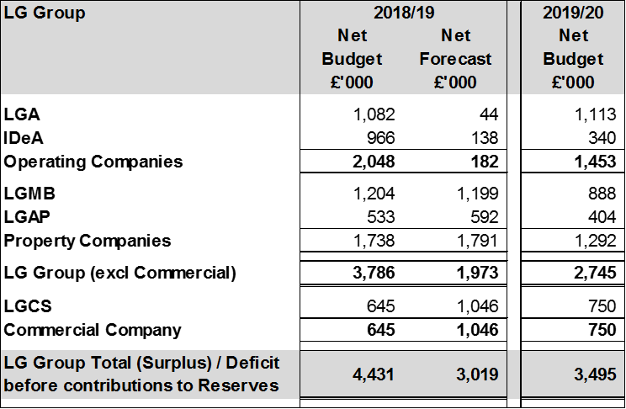

1. **The LGA’s proposed consolidated budget for 2019/20 will be balanced by drawing down on previously created Reserves.**

Implications for Wales

1. None.

Financial Implications

1. As above.

Next steps

1. Members are asked to:
   1. Agree the LG Group’s budget for 2019/20 as recommended by the LGA Leadership Board; and
   2. Endorse the Leadership Board’s delegation to the Chairman and Group Leaders, in consultation with the Deputy Chief Executive, of approval to make necessary adjustments to reflect the final grant notification from MHCLG.

**APPENDIX A1 – 2019/20 Budget - Group Budget**



**APPENDIX A2 – 2019/20 Budget – Group Net Financial Summary versus current year**

